BAB III

PERANCANGAN PENGEMBANGAN SOFTWARE

1. USECASE DIAGRAM
2. Usecase Guru

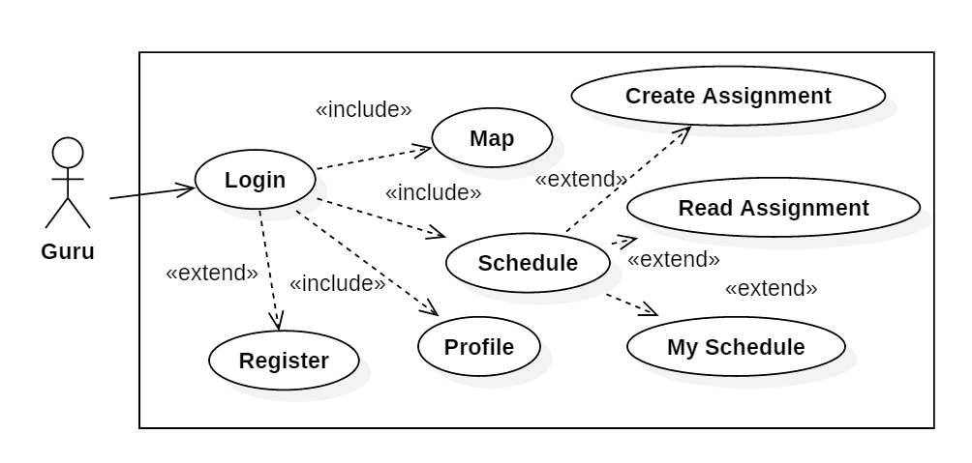

1. Usecase Siswa

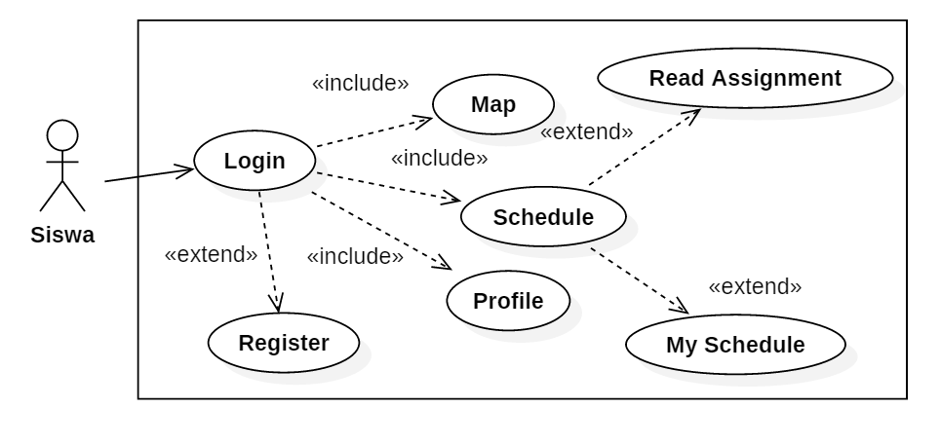

1. Usecase Admin

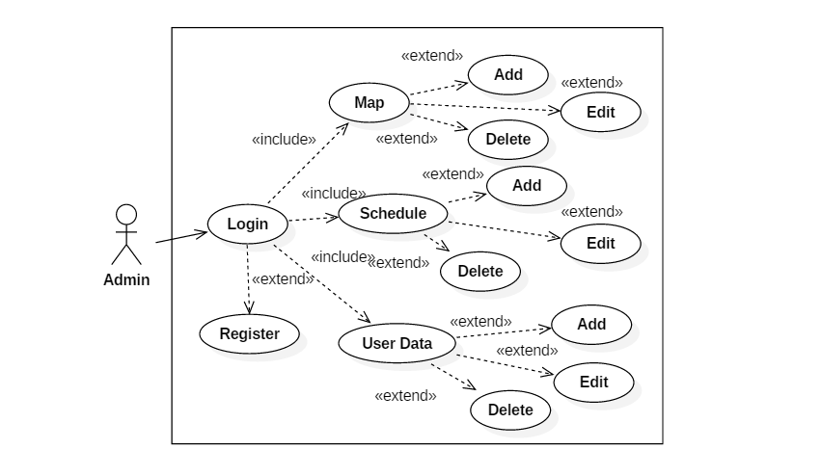

1. ACTIVITY DIAGRAM
2. Activity Login

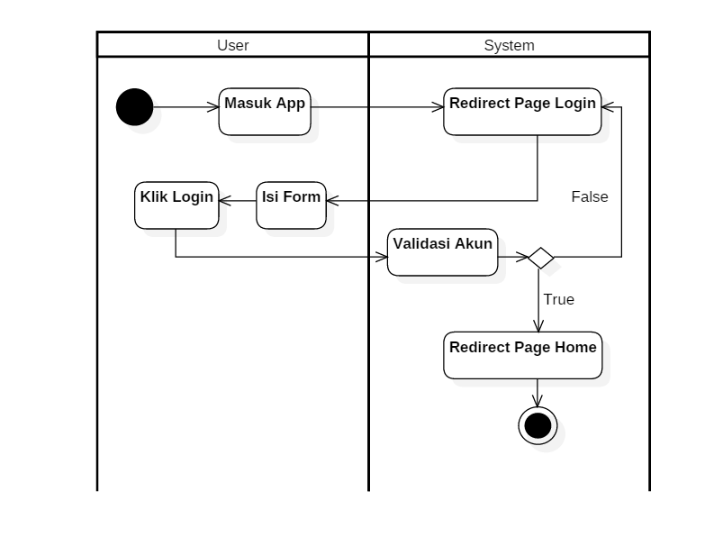

1. Activity Search Filter

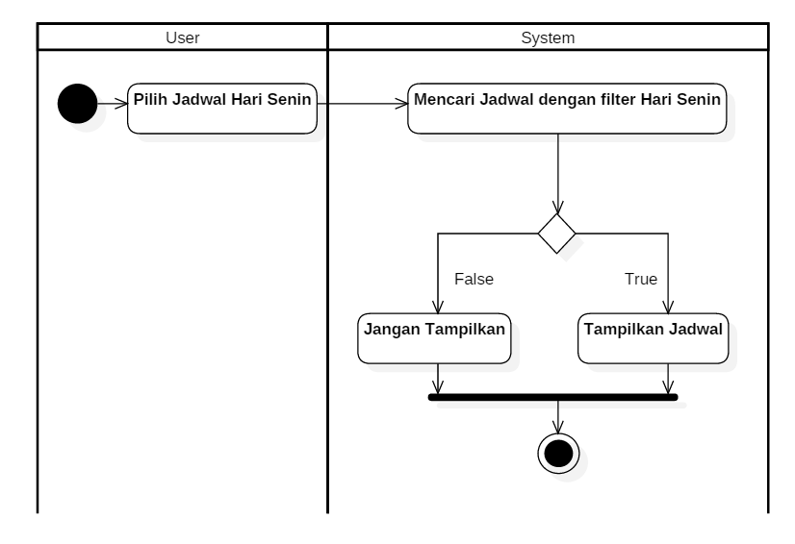

1. CLASS DIAGRAM

